

FPT University
Training Center Programming FPT - APTECH



SPUPORTIVE LEARNING

❖ SEM : IV
❖ CLASS : C0810G
❖ Group : Group 2
❖ TEACHER : Đỗ Quốc Bình
❖ Members :
- Dương Văn Định (Leader)
- Phan Văn Tuyền
- Trần Trung Hiếu
- Phạm Xuân Nam
- Vũ Đức Giang

Contents
I) Problem Definition: 2
1) Problem Abstraction:. 2
2) The Current System: 2
3) The Proposed System: 2
4) Development Environment: 2
II) Requirements and business Flow: 3
A. Customer Requirement Specification: 3
1. System Requirement Specification : 3
2. Functionality for Student: 3
3. Functionality for Staff: 4
4. Functionality for Admin: 4
B. Activity Diagram 4
1. Login Activity Diagram: 5
2. Student Activity Diagram: 6
3. Staff Activity Diagram: 7
4. Admin Activity Diagram: 8

- Problem Definition:
- Problem Abstraction: The thirst for learning, upgrading technical skills and applying the concepts in real life environment at a fast pace is what the industry demands from IT professionals today. However busy work schedules, far-flung locations, and unavailability of convenient time-slots pose as major barriers when it comes to applying the concepts into realism. And hence the need to look out for alternative means of implementation in the form of laddered approach.
- The Current System: The above truly pose as constraints especially for our students too! With their busy schedules, it is indeed difficult for our students to keep up with the genuine and constant need for integrated application which can be seen live especially so in the field of IT education where technology can change on the spur of a moment. Well, technology does come to our rescue at such times!!
- The Proposed System: Keeping the above in mind and in tune with our constant endeavour to use Technology in our training model, we at Aptech have thought of revolutionizing the way our students learn and implement the concepts using tools themselves by providing a live and synchronous eProject learning environment!
- Development Environment:
Hardware :
- Server:
- Pentium IV 3.06GHZ,RAM 1GB,HDD 160GB…
- Client:
- Pentium III 900GHZ,RAM 128MB,Sound & VGA Card…
Software :
- Server:
- OS Windows Server 2000 or Windows Server 2003.
- MS SQL Server 2005.
- Client:
- Window98 or higher operating system.

Developer Tools :
- Language Used : Java Web Application and JSF 2.0 PrimeFaces 2.2.1.
- Database : MS SQL Server 2005
- Design tool : Netbean 6.9.1

- Glassfish 3.0 or higher.

- Requirements and business Flow:
- Customer Requirement Specification:

  - System Requirement Specification :
- Student
- Staff
- Admin

  - Functionality for Student:

2.1. View Information:

Open website Student can view the brief description about Schools, about the assignments,and about the news.

2.2. Login:

Students must login for upload or download

2.3. Feedback:

Student can give feedbacks about the site or ask the queries if any.

2.4. Mark:

a. View details marks of assignments by roll number.

b. The students should be able to view the marks that are assigned for their assignments, through the link marks

2.5. FAQ’s:

Student can view the FAQ’s as created by the admin.

  - Functionality for Staff:

3.1. View Information:

Open website Staff can view the brief description about Schools, about the assignments,and about the news.

3.2. Login:

a. Staff must login to view, delete, upload assignments.

b. Staff can viewing uploaded files by student by roll number.

c. The staff will assign the marks after evaluating the assignment once they are downloaded. The marks assigned will then be uploaded on the site through the links “marks”, based on the roll number.

d. Staff to answer students' questions.

- Functionality for Admin:

4.1. Login:
a. The administrator will have the rights for creating, editing and deleting the usernames and passwords (username and passwords are to be created based on the batch, year, and semester. These are unique for the whole batch) .
b. The administrator will have the right to answer the query, view or edit or delete the FAQ s.
- Activity Diagram

1. Login Activity Diagram:
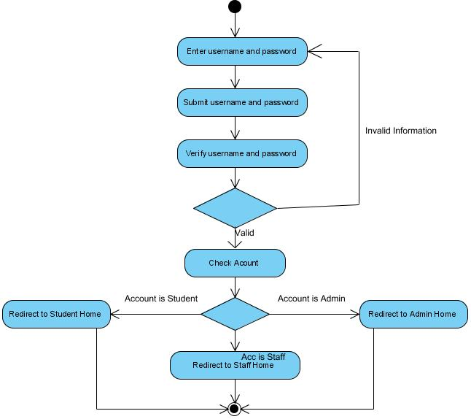

- Student Activity Diagram:

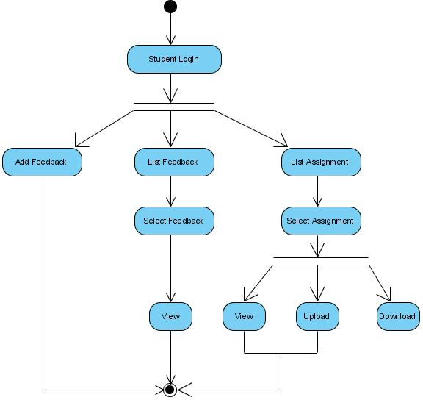

- Staff Activity Diagram:

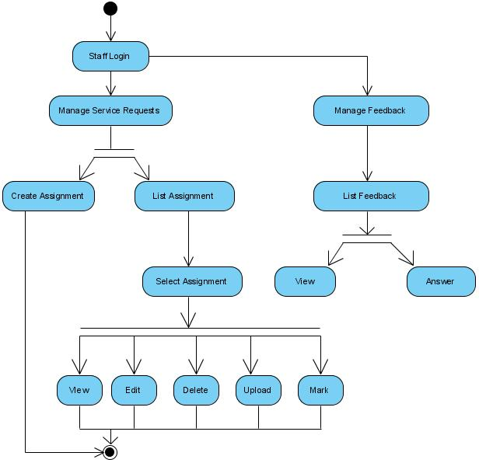

- Admin Activity Diagram:

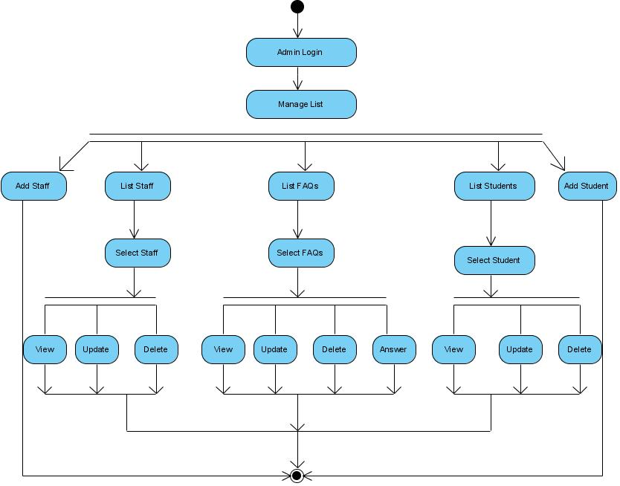

- Database Design

